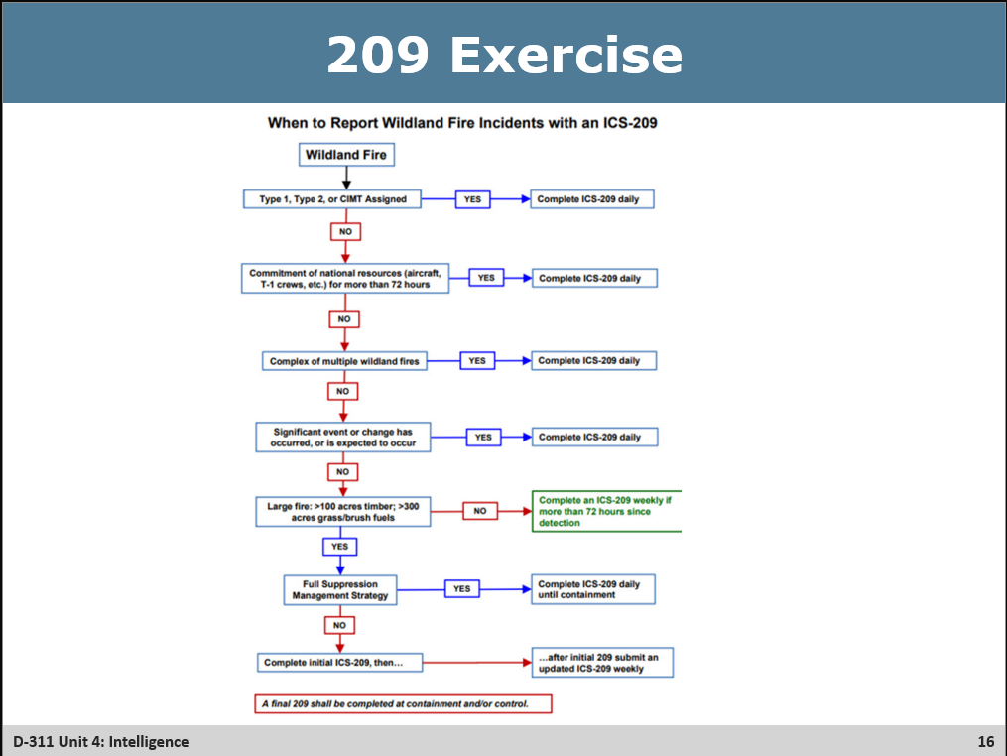
❑ Pass out the strips from the following page, 1 per group, and give them 5 – 10 minutes to determine for each fire.
- Does this fire need to be completing a 209, and if so, how often?
- Is this a Ctn or Comp Fire?
If there are less than 7 groups, review spare strips after the groups present their answers. Question 7 may be a good class-wide discussion.
Answers – 1) Yes a 209 is required, with daily submittals. Ctn fire because Full Suppression
2) No 209 is needed– discuss that Timber with Grass understory fuel type means that the carrying fuel is grass, and thus they need over 300 acres for size to require a 209. Ctn fire due to Full Suppression
3) Yes a 209 is needed, but only once a week due to a mix of strategies. Comp fire due to the mix of strategies
4) Yes it will still need a 209, but now it will be daily. Due to this change of the strategy, it will now be a Ctn fire.
5) Yes this fire still needs a Daily 209, however a conversation could be had with the GACC (and them with NICC) to see if weekly submissions will suffice.
6) Yes has now become a Complex, so it will need a daily 209. It cannot be determined if this will be a Comp or Ctn due to strategy not being provided – typically they would be full suppression fires, but the fires all need to have the same strategy to be complexed together. The Individual fires’ 209s will be finalized and added to the complex.
7)This Fire does not REQUIRE a 209 at this time because it doesn’t have the complex team yet, meet the size limit yet, or meet any other requirements per the prompt. It could be argues the fire is on the verge of a “significant event” as well. It would be advised to start the 209 due to the nature of the incident to make sure that this fire is getting GACC and NICC attention. Ctn Fire.

1) New Fire today, the Yankee. It is 150 acres in timber slash understory. Strategy is going to be Full Suppression.
Does this Fire need a 209, and if so, how often? Is this a Ctn or Comp Fire?

2) New fire from the weekend, Whiskey. This morning’s scouting mission shows it at 120 acres in Timber grass understory. Strategy is Full Suppression.
Does this Fire need a 209, and if so, how often? Is this a Ctn or Comp Fire?

3) Ongoing fire the Delta. It has been holding around 200 acres in tall grass fuels, however this morning it got into a heavy pocket and took off, estimating 500 acres per Infrared UAS flight. Strategy remains 50% suppression, 25% confine contain, and 25% monitor.
Does this Fire need a 209, and if so, how often? Is this a Ctn or Comp Fire?

4) Ongoing large fire, the Juliette. It has been holding around 1000 acres in some chapparal fuels. It was getting a weekly 209. Due to growth last night towards a community that was previously thought to be safe, strategy will be changing from 90% suppression and 10% point-zone-protect to now being 100% suppression.
Does this Fire need a 209, and if so, how often? Is this a Ctn or Comp Fire?

5) A Large fire, Kilo, is at 2500 acres, with a 100% suppression strategy. The Campbell Type 3 team has bundled up most of the containment and will be handing it off to the local unit today. The strategy will not be changing, but with over 85% containment the local FMO insists that significant changes are over and they will be chinking along for a couple weeks to get it to 100% containment.
Does this Fire need a 209, and if so, how often? Is this a Ctn or Comp Fire?

6) You have 3 fires, the Tango, Uniform, and Victor fires. They are going to be complexed with the incoming CIMT Hammer team. Tango previously had a daily 209, Uniform a weekly one, and Victor was not receiving a 209.
Does this Complex need a 209, and if so, how often? What becomes of the individual fires’ 209s? Is this a Ctn or Comp Complex?

7) Your Zone has a 70 acre fire in timber, That will be Full Suppression but there are many factors at play such as communities threatened, holiday weekend coming up, many Threatened and Endangered Species in the area, and being a critical watershed that could threaten the big city down in the valley’s livelihood. The Agency Administrator has decided that due to this complexity, a CIMT needs to be ordered. That CIMT can be there in 2 days, the local type 3 team will begin managing tonight and hand the fire over to the CIMT when they arrive.
Does this Fire need a 209, and if so, how often? Is this a Ctn or Comp Fire?

1) New Fire today, the Yankee. It is 150 acres in timber slash understory. Strategy is going to be Full Suppression.
Does this Fire need a 209, and if so, how often?

2) New fire from the weekend, Whiskey. This morning’s scouting mission shows it at 120 acres in Timber grass understory. Strategy is Full Suppression.
Does this Fire need a 209, and if so, how often?

3) Ongoing fire the Delta. It has been holding around 200 acres in tall grass fuels, however this morning it got into a heavy pocket and took off, estimating 500 acres per Infrared UAS flight. Strategy remains 50% suppression, 25% confine contain, and 25% monitor.
Does this Fire need a 209, and if so, how often?

4) Ongoing large fire, the Juliette. It has been holding around 1000 acres in some chapparal fuels. It was getting a weekly 209. Due to growth last night towards a community that was previously thought to be safe, strategy will be changing from 90% suppression and 10% point-zone-protect to now being 100% suppression.
Does this Fire need a 209, and if so, how often?

5) A Large fire, Kilo, is at 2500 acres, with a 100% suppression strategy. The Campbell Type 3 team has bundled up most of the containment and will be handing it off to the local unit today. The strategy will not be changing, but with over 85% containment the local FMO insists that significant changes are over and they will be chinking along for a couple weeks to get it to 100% containment.
Does this Fire need a 209, and if so, how often?

6) You have 3 fires, the Tango, Uniform, and Victor fires. They are going to be complexed with the incoming CIMT Hammer team. Tango previously had a daily 209, Uniform a weekly one, and Victor was not receiving a 209.
Does this Complex need a 209, and if so, how often? What becomes of the individual fires’ 209s?

